Question 5:
Create a dictionary of five animals and the sounds they make. Print each pair.
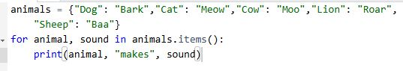
Output:
